**THE SUPERIOR UNIVERSITY LAHORE**



TECHNICAL & BUSINESS WRITING

RESEARCH PAPER

Name: Maida Haq

Roll No: Bcsm-F20-330

Semester: BScs (5th A)

Department: Computer Science

Submitted to: Mam Qaisra Honey

**A Targeted Screening Program for Renal Cancer**

## Abstract:

An estimated 31,900 new cases of renal carcinoma were reported in the United States in 2003, making up about 3% of all adult malignancies. Surgery may be able to treat renal cancer in the early stages of the illness's natural history, but the likelihood of survival is slim if the disease shows any evidence of metastasis, despite the anecdotal reports of instances with prolonged survival. Actually, there are still issues with the way that metastatic kidney cancer is treated. With very low response rates and no appreciable improvement in overall survival, systemic treatment with single agents and polychemotherapy, with or without cytokine-based immunotherapy, has not been effective. In both localized and advanced disease, this study highlights the most intriguing problems with traditional therapy approaches. The potential clinical applications of novel techniques including allogeneic cell transplantation, monoclonal antibodies, vaccinations, gene therapy, and angiogenesis inhibitors are also highlighted.

Introduction:

Renal cancer kills over 26,000 people per year in Europe and 13,000 in the United States, and many people in Pakistan also suffer from this disease. If identified before metastatic spread, kidney cancer is usually surgically curable, whereas the median survival with cancer is only 2 years. Turney et al. proposed in 2006 that a screening program using ultrasound could have a major impact on renal cancer mortality, and that the treatment of renal masses would not be of net benefit in older populations. In the past 7 years, however, the natural history and epidemiology of renal cancer have become much clearer. Moreover, nephron-sparing surgery and minimally invasive ablation are now better established, changing the cost-benefit ratio for treatment in older populations. These developments mean that a targeted renal cancer screening program is now a real option. The evidence for such a screening program is presented in three parts: first, an update on the natural history and risk factors; second, a calculation of the benefits and harms of screening in different populations, and third, lessons from other cancer screening programs. Finally, a clinical algorithm to aid with screening and treatment choices is presented.

Diagnosis of renal cancer is made by imaging of the kidneys: a solid mass is appearing in the patient’s kidney that can spread all around and cause the tumor. A histological analysis reveals that over 85% of lumps are cancerous. Historically, imaging of the kidneys was performed in symptomatic patients. However, many renal tumours are discovered as unintentional discoveries with the increased use of imaging for other abdominal ailments. The bulk of kidney malignancies now are "incidentalomas," as the term goes. Although incidental renal masses are rarely harmful, they are often smaller than symptomatic masses. Despite receiving treatment, 14.4% of patients in a study of nearly 4,000 people with incidental kidney tumours passed away from the disease over an average 4-year follow-up. The majority of solid renal masses are thought to be cancerous and are removed. Thus, information on the natural history of untreated masses is scarce. The average tumour size at diagnosis was found to be 2.6 cm, with a mean growth rate of 0.28 cm per year, in a meta-analysis included 234 patients who did not have urgent surgery. In a later study of 106 patients, it was discovered that 33 percent of the masses did not grow over a 25-month follow-up period, while in a prospective study of 82 patients who underwent active surveillance for a median of three years, the majority of the masses grew, but 10 percent remained stable, and 5 percent regressed. Whether these lumps were benign is unknown. Average survival is shortened by higher tumour size because larger masses frequently form more quickly than smaller ones. It may take several years for a mass to grow to a size that causes issues if the initial growth rates are slow. The majority of incidental masses will nevertheless advance to clinical disease, with a sojourn time of between 3.7 and 5.8 years, according to a comparison of the incidence of incidental renal masses and symptomatic renal cancer. The goal of screening is to find cancer early, that is, while the tumour is tiny, circumscribed, and curable. Since most tiny masses expand slowly, it appears that this goal can be accomplished.

Programs for screening are most effective when they focus on high-risk groups. With respect to gender, age, and race, kidney cancer incidence varies. The frequency is nearly twice as common in men as it is in women, rises with age, is most prevalent among African Americans, and is least prevalent among Asian Americans, as well as in Pakistan. The risk of kidney cancer can be increased by a variety of medical and lifestyle factors. Recognized risk factors for cancer include smoking, obesity, high blood pressure, family history, multiple pregnancies in women, end-stage renal disease, and exposure to toxins. Renal cancer risk is doubled by heavy smoking, severe hypertension, and morbid obesity, and is quadrupled by a family history of the disease. As a result, some population groups are more vulnerable. In comparison to a normotensive, non-smoking, slender male, an obese, hypertensive man who smoked extensively would have an 8-fold increased risk of kidney cancer, and a thin woman would have a 16-fold increased risk. The discovery of these risk variables allows for the screening of high-risk populations.

A programe for screening for kidney cancer would ideally result in a decrease in cancer mortality. The cost of screening, the direct harm from screening investigations, and the harm from unneeded operations like biopsies or surgery in people who have received a false-positive or an excessive diagnosis are among the potential harms (i.e., a positive screen in a patient with a cancer that would not have caused symptoms in their lifetime). Based on illness incidence, screening effectiveness, and current surgical results in comparison to the natural course of untreated disease, the benefit of therapy can be determined. The rates of treatment complications and the number of cases of overdiagnosis or erroneous diagnosis can both be used to quantify the harm caused by overtreatment.

RESEARCH QUESTIONS:

Throughout my research paper, I will explore the question regarding this research paper

which is as follow

What type of kidney cancer people have? Rheumatoid cell carcinoma is the most common kind of kidney cancer (RCC). This form of tumor makes up about 90% of kidney cancer tumors. If you have this form of kidney cancer, one or both of your kidneys may contain many tumors. By the time they are diagnosed, they may be rather enormous. However, the majority of kidney cancer cases are discovered before the disease has progressed to other organs. There are various RCC varieties. These types are recognized by a medical professional known as a pathologist by examining the cancer cells under a microscope. The various RCC types include:

empty cell: The most typical RCC is this one. The cancer cells appear transparent or pale.

Papillary: This RCC variant is the second most typical. These tumours have little, finger-like growths.

Chromophobe: It's an unusual variety of RCC. The cells are bigger than those of other RCC types.

gathering duct: Also, an uncommon variety of RCC, this. The cancer cells resemble amorphous tubes.

Unclassified: This comprises tumours that contain cells from multiple cancer types. Tumor having cells that don't fall within the other categories are also included.

What Causes Kidney Cancer? When DNA in the cells of one or both kidneys mutate, it can result in unchecked cell division and proliferation, which is what causes kidney cancer. Although the precise origin of a person's kidney cancer may not be understood, there are some risk factors that are closely associated with the illness, such as obesity and tobacco use. A greater risk of acquiring the disease also exists in those with specific genetic cancer syndromes or a family history of kidney cancer.

How we diagnosis this? Approximately half of kidney masses are discovered by accident. Frequently, they are identified during routine screening or when a patient visits a doctor with another issue. A urologist may be recommended if your doctor suspects you have renal issues. An expert in the urinary system is known as a urologist. There are no standard testing procedures to detect kidney masses. To find out more about your kidneys, your doctor may perform a variety of tests. You may anticipate the following tests and procedures:

to examine the blood for illness indications, complete a blood count (CBC).

urine test to look for protein, blood, and infections

Checks for kidney function, such as measuring serum creatinine levels or performing other tests to see if the kidneys are removing waste,

to visualize your kidneys via ultrasound

Diagnose and classify kidney masses using MRI and CT scans

finding out if the cancer has spread using a bone scan and a chest x-ray

Your tumor kind will be determined via a kidney mass biopsy.

What are the [treatment options](https://www.cancer.org/cancer/kidney-cancer/treating.html)? There is the treatment of renal cancer according to the different stages. Every stage has a different type of treatment. Patients with renal cell cancer can choose from a variety of treatments. Standard (currently used) therapies include some, while others are undergoing clinical studies. A treatment clinical trial is a type of research study designed to find novel cancer treatments or to better understand existing ones. When clinical studies demonstrate that a new treatment is superior to the accepted practice, the new practice may be adopted as the accepted practice. Patients might want to consider enrolling in a clinical study. Only people who have not started therapy are eligible for some clinical trials.

LITERATURE REVIEW:

Over 50% of tumors in renal cell carcinomas (RCCs) may be discovered inadvertently, and symptoms typically don't manifest until late in the disease. The so-called "classic trifecta" of flank discomfort, hematuria, and flank fullness only occurs in 10 to 15% of patients. Historically, asymptomatic hematuria has been seen in approximately 60% of patients. Fatigue, weight loss, fever, night sweats, malaise, hypertension, and anemia are other symptoms. Tumor invasion and development into the renal vein and inferior vena cava, which may block the testicular vein, can result in varicocele. When present, hypercalcemia signals a paraneoplastic condition or bony metastases.

Osteolytic bone metastasis frequently leads to pathologic fractures, spinal cord compression, and hypercalcemia. Back pain that is excruciating, acute, and band-like may be present as a result of vertebral collapse and spinal cord compression brought on by metastatic renal cell carcinoma and may aid in the diagnosis of metastatic disease. Because paraneoplastic syndromes are common, renal carcinoma is known as the "great mimic." It is capable of producing a variety of chemicals that trigger hypercalcemia, erythrocytosis (erythropoietin), Cushing syndrome (ACTH), and other conditions.

One-third of RCC patients are diagnosed with metastatic illness. In order to determine whether metastasis to the lungs (75%), bone (20%), liver (18%), CNS (8%), and other organs has occurred, a physical examination should be performed.

RESEARCH METHODOLOGY:

I consulted a variety of sources, including surveys, journals, internet articles, papers, documents, and more, to achieve my research objectives. All of them were quite helpful to me in completing my research obligations.

For improving patient treatment of renal cancer patients, we created and optimized novel models and tools in this area. We identified diverse multiclonal populations with epithelial and mesenchymal features in addition to stem cell phenotype from freshly harvested tumor specimens. When orthotopically injected and serially transplanted into immunocompromised mouse hosts, these cells were able to develop parental tumor and maintain their long-lasting tumor-propagating potential, which allowed for therapeutic monitoring both in vitro and in vivo.

Aalgorithm for the treatment and screening of renal cancer with precision. Based on established risk factors for kidney cancer, patients are given a score (A). (B) Screening by ultrasound or CT scan is initiated with a score of five or above, but not with a score of five or below. A biopsy or follow-up scan can be used to describe a small renal mass found during screening before therapy, but a large mass seen during screening is treated right away. Treatment options for detected masses include active surveillance, surgical excision, or ablation of the mass; they are impacted by the patient's comorbidities and personal preference. Calculated tomography is often known as a CT scan.

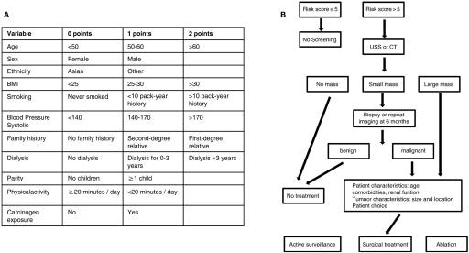

RATIO OF CANCERS IN WORLD-WIDE:

This is the overall ratio of all the types of the cancer which is in all around the world many people affected from these diseases. There is the ranking in the different type of cancer. In the world, breast and lung cancer accounted for 12.5% and 12.2% of all new instances of cancer, respectively. In 2020, breast and lung cancer accounted for 12.5% and 12.2%, respectively, of all newly diagnosed cases of cancer. Then the renal cancer comes and now days this is the major diseases. The many hospitals allocated for these types of patients. In Pakistan the hospitals like INMOL Cancer Hospital, Jinnah Hospital, Shaukat Khanum Memorial Cancer Hospital & Research Centre, Cancer Care Hospital and Research Centre, PKLI Hospital. This is the major hospital in which patients’ treatment held properly.

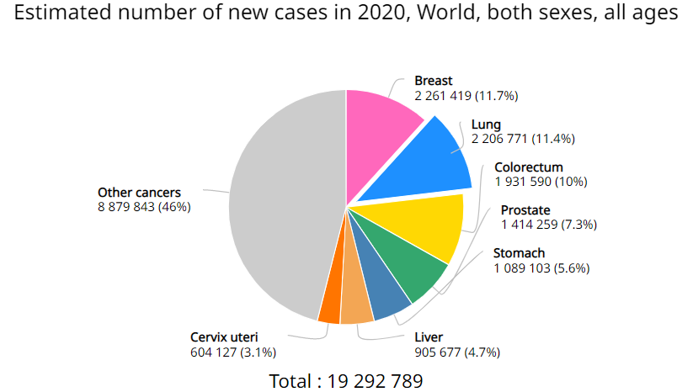

## Global cancer incidence in men:

The ratio of kidney cancer and new cases in men is

|  |  |
| --- | --- |
| NEW CASES | RATIO |
| 271,249 | 2.9% |

## Global cancer incidence: both sexes

The overall ratio of kidney cancer and new cases in both gender is

|  |  |
| --- | --- |
| NEW CASES | RATIO |
| 431,288 | 2.4 |

## Global cancer incidence in women

The ratio of kidney cancer and new cases in women is

|  |  |
| --- | --- |
| NEW CASES | RATIO |
| 160,039 | 1.8 |

REFERENCES:

1. Boyle P., Autier P., Boniol M., Heanue M., and Colombet M. estimations of cancer mortality and incidence in Europe in 2006. (2007) 18(3):581–92; 10.1093/annonc/mdl498; Ann Oncol.

2. Cancer J (2008) 14(5):288–301 10.1097/PPO.0b013e3181867628 Chow W-H, Devesa SS. Contemporary epidemiology of renal cell cancer.

3. Derweesh IH, Blute ML, Chow GK, Belldegrun A, Campbell SC, Novick AC, and others Management guidelines for the clinical T1 renal mass. 10.1016/j.juro.2009.07.004 J Urol (2009) 182(4):1271-9

4. Motzer RJ, Hutson TE, Tomczak P, Michaelson MD, Bukowski RM, Oudard S, et al. Overall survival and updated results for sunitinib compared with interferon alfa in patients with metastatic renal cell carcinoma. *J Clin Oncol* (2009) 27(22):3584–90 10.1200/JCO.2008.20.1293

5. Turney BW, Reynard JM, Cranston DW. A case for screening for renal cancer. *BJU Int* (2006) 97(2):220–1 10.1111/j.1464-410X.2006.06021

6. Parkinson R, Ramsey S, Aitchinson M, Kumar M, Parsons K. Letters in response to Turney et al 2006. *BJU Int* (2006) 97:1121–4

7. El Dib R, Touma NJ, Kapoor A. Cryoablation vs radiofrequency ablation for the treatment of renal cell carcinoma: a meta-analysis of case series studies. *BJU Int* (2012) 110(4):510–6 10.1111/j.1464-410X.2011.10885

8. Cancer statistics, 2003 by Jemal A., Murray T., Samuels A., Ghafoor A., Ward E., and Thun M.J. CA 53: 5-26, Cancer J Clin, 2003.

9.Smoking and health, including a comment on kidney cancer. Tavani A., La Vecchia C. 2000. Contrib Nephrol 130: 11–20.

10. Regular use of analgesics is a risk factor for renal cell carcinoma, according to Gago-Dominguez M., Yuan J.M., Castelao J.E., Ross R.K., and Yu M.C. Br J Cancer 81 (1999) 542–548.

10.Chen SC, Kuo PL. Bone Metastasis from Renal Cell Carcinoma. Int J Mol Sci. 2016 Jun 22;17(6) [[PMC free article](https://www.ncbi.nlm.nih.gov/pmc/articles/PMC4926516/)] [[PubMed](https://www.ncbi.nlm.nih.gov/pubmed/27338367)]

11.Luciani LG, Cestari R, Tallarigo C. Incidental renal cell carcinoma-age and stage characterization and clinical implications: study of 1092 patients (1982-1997). Urology. 2000 Jul;56(1):58-62. [[PubMed](https://www.ncbi.nlm.nih.gov/pubmed/10869624)]